
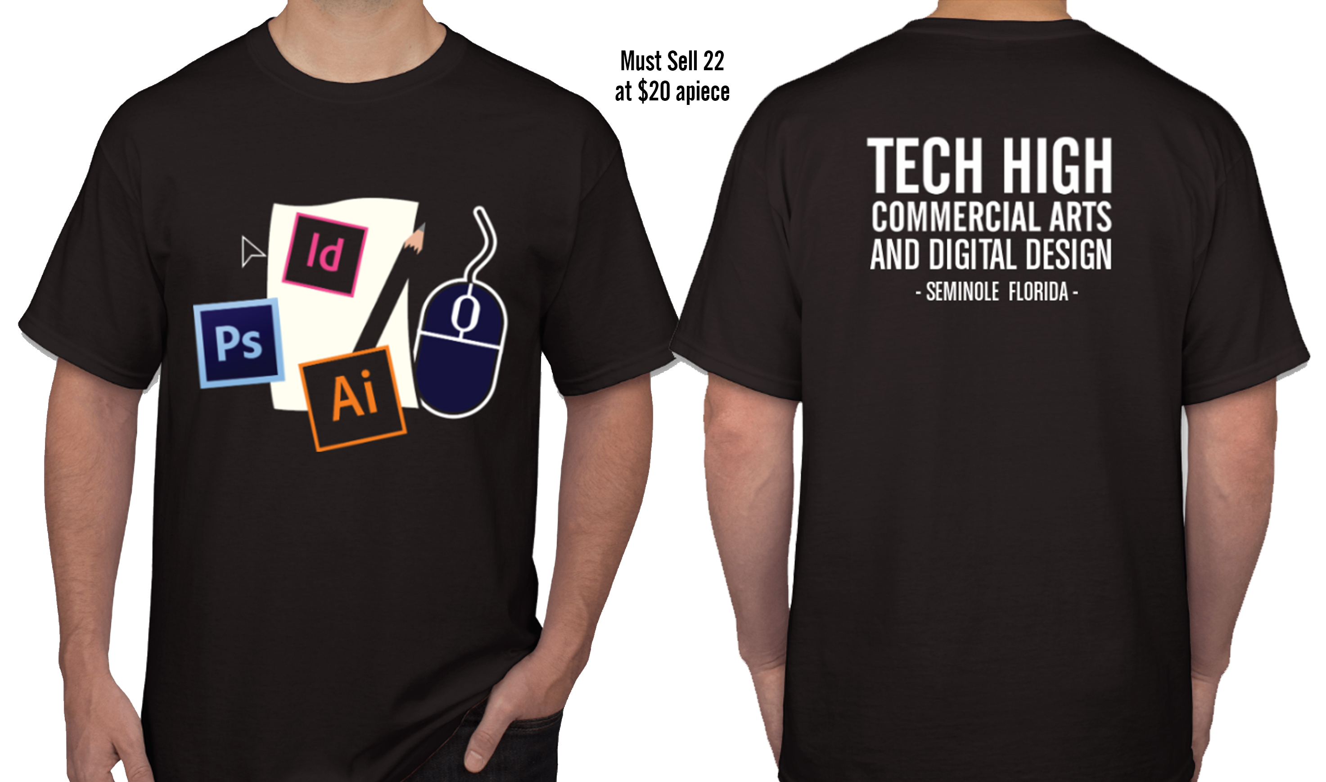

Tech High Spirit Week T-Shirt Design

Meets Florida Standards: 05.02 05.08 07.04 – 07.09 10.02 – 10.04 09.14

TASK: Create a t-shirt design for the Tech High Spirit Week (2 pts)

YOU WILL NEED TO:

Create at least 3 thumbnail sketch ideas of a t-shirt design.
- Incorporate the Tech High logo into the design.
- Critique your ideas with the class.
- Create a final of your best ideas in Illustrator.

OUTCOME:
Students work to create a mainstay of commercial artwork – the promotional t-shirt vehicle. This exercise is for a small client with a small budget and can benefit the serious student’s portfolio.

YOU WILL NEED TO # 1:
Brainstorm ideas for the class shirt
- Ideas are for a design which can represent the school. Color choices forthcoming. Watch class website.
- Commercial Art & Digital Design is the term. English Gothic is the font. It’s in the class resource folder.

YOU WILL NEED TO # 2:

Create three thumbnail sketch ideas for each of your t-shirt and slogan ideas
- Create three thumbnail sketches using the t-shirt thumbnail paper. Make sure they’re numbered and show values. Shirt color is coming soon. Watch www.Juularts.com
- Once you have your thumbnails finished, see Mr. Juul to discuss your ideas.

YOU WILL NEED TO # 3:

Critique process with the class
- Participate in a critique with the class.
- Be able to tell us what you like or don’t like about your own design
- Be open to constructive criticism, changes or suggestions.

YOU WILL NEED TO # 4:

Create your final in Illustrator
- Once your ideas have been critiqued, create the artwork necessary for your shirt to be printed.
- 8 ½” x 11” (or regular Illustrator file if using Illustrator)

TIPS TO REMEMBER

- Large BOLD Fonts work best
- Design for the front center of the shirt.

