
PROJECT: Non-Profit Animal Rescue Logo Design

MEETS FLORIDA STANDARDS:

- Demonstrate proficiency w elements & principles of design.
- Demonstrate proficiency in art and design skills.
- Demonstrate an understanding of type design.
- Demonstrate proficiency in layout.
- Demonstrate proficiency in applied design.
- Demonstrate proficiency in graphic art computer skills.
- Demonstrate proficiency in graphic production.
- Demonstrate an understanding of employability in commercial art and graphic media.
- Demonstrate an understanding of entrepreneurship.
- Demonstrate proficiency in website planning and the design process.
13.0 Incorporate images and graphical formatting on a webpage.

TASK: Design a logo for High Desert Horse Rescue
Looking for a horse head (vector) silhouette but made of twisted juniper. There is a local real estate company that has a logo similar but it is a stag. See Resources below.

A font for the name has not been picked yet.

WORK FLOW:
- Spec Sheet with minimum of six different logo concepts
- Critique and feedback with Mr. Juul
One in white on black background
- Critique and feedback with your peers
- Adobe Illustrator. The final needs to be a .ai file

RESOURCES:

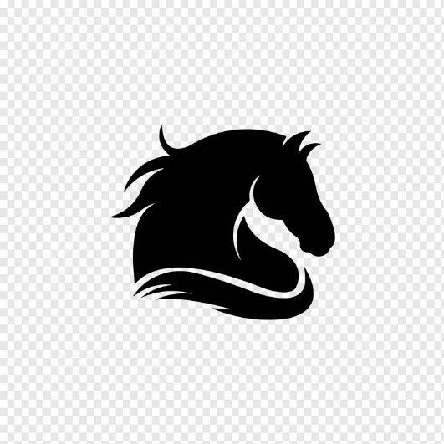
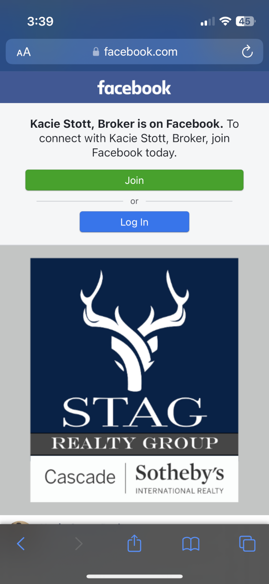

OUTCOME:
Students will pratice the Design Process, Concept Sketching, Logo Design, Use of Adobe industry Software. Students will also be responsible for working to specifications with a customer.

PRE-PRODUCTION
Brainstorm and gather information related to your inspiration.
Gather a logo design styles example sheet with other animal rescue logos
- Visit the Websites above for any logos, words, information that could inspire a design
- Sketch a minimum of six ideas for this logo.
- Critique with Mr. Juul
- Either make recommended changes, start again or proceed to production

PRODUCTION & POST PRODUCTION

Production.
- Using Photoshop for concept art or Adobe Illustrator all the way, design your two best ideas.
- Once you have these finished, peer critique process.
- Either make recommended changes, start again or proceed to your final artwork / logo
- You may be asked to email your ideas to the client

Post Production
- You will be asked to e-mail Save an .ai file, .png file with transparent background and a jpeg with both designs in color and black and white.
- Prepare an 81/2” x 11” file that showcases both of your logos and print this.
- You may be asked to send a final electronic version to the client or make changes as they would like.

Grading Rubric – 3 points

An A grade will look like: 3 points
Your attention to detail is self evident. You followed the outline exactly as explained. You incorporated original thoughts and ideas. The artwork is personal, of your choice and of professional standards you set. You followed Pre-Production – Production and Post Productions instructions.

A B grade will look like: 2.5 points
Your attention to detail is evident in parts of your final. You followed the outline mostly as explained. You incorporated some original thoughts and ideas. Your idea and artwork is of professional standards, but has some room for revisions. Your letter may contain a few typos.

A C grade will look like: 2 points
Your attention to detail is evident in some of your final. You followed the outline mostly as explained, but are missing one or more key elements asked for. You incorporated a few original thoughts and ideas. The artwork is of minimal professional standards, has some room for improvements and revisions and should be corrected before mailing. Your letter has spelling and punctuation errors that should also be looked at before mailing.

A D grade will look like: 1 points
Your attention to detail is evident in almost no part your final. You did not follow the outline as explained, and are missing more than one key elements asked for. There is no thought given to originality. It’s minimal or even too much. The artwork is not of professional standards yet and should be corrected if giving this to a client. Your letter has spelling and usage issues. Maybe does not make much sense.

A Failing grade will mean: 0 points
The project is either not turned in, incomplete and there was no attention paid to the instructions provided. There is no thought given to originality. The artwork is not of professional standards. The idea most likely should have been abandoned in favor of another approach.

