
PROJECT: Comic Book Character & Profile

MEETS FLORIDA STANDARDS: 01.0, 02.0, 03.0, 04.0, 08.0, 09.0, 10.0, 19.0, 21.0, 23.0

TASK: Make an original Super Hero out of your inspiration
Your job is to take an inspiring character from a famous movie, book, actor, author, artist, TV actor or sports figure and conceptualize and realize them in comic book character form. Can be yourself also.

WORK FLOW:
- Choose who you would like to create a character for.
- What are the strengths, special powers, weaknesses?
- Figuring out the illustration style of the character
- Creating a 180 view – Front Side Back
- Creating a super hero logo for your character
- Creating their backstory / weaknesses / enemy

OUTCOME & DUE DATE:
- Students use their design skills and writing skills to create a unique character and design the look of that character.
- Students utilize logo design, character design typography and layout.

PRE-PRODUCTION
- Brainstorm and gather information related to your inspiration
- Figure out how to create a cartoon version of a real face
- Gather information and images relating to your proposed character.
- Resources for comic strips and comic characters

PRODUCTION

Concept sketch and create your character
- Create that artwork. This is a personal piece of work. The dimensions, mediums, colors and execution are going to be up to you. Use the software ComicGen to create one, illustrate it yourself and scan it, illustrate it digitally.

- Create a 180 degree look at your character – Front – Back and side stances. See the example below.

Concept sketch and create the characters logo
- Super Hero Logo Examples.

You’re required to complete a minimum of three logo idea concept sketches for your hero’s logo.
It can be a trademark logo, logotype or symbol.

Concept sketch and create the comic book character profile
- Example 1 (Comic Book Guy at the bottom of the page) Example 2

You’re required to complete concept sketches for your hero’s character profile, then create the profile. Keep in mind the principles of HIERARCHY, LAYOUT, TYPOGRAPHY.

POST PRODUCTION

Save and Print your cover and character profile.
- Using Photoshop, set up a 8.5” w x 11” h file.
- Import or paste a copy of your character profile on left side and comic book cover on the right
- Save a 300 dpi jpeg or .png file
- Print your final. Upload your final to Focus. REMEMBER: Your final should look as real as possible to a comic book cover. It should have a logo (DC / Marvel / Etc

CHARACTER PROFILE Example 180 DEGREE Example
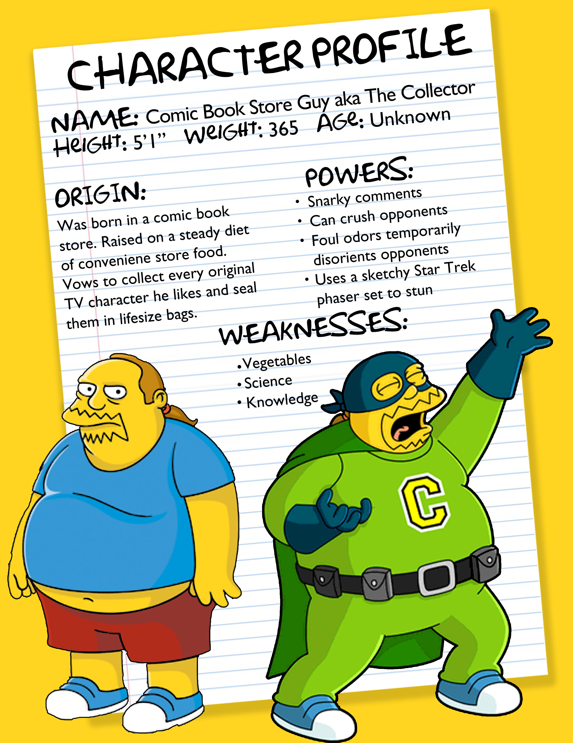
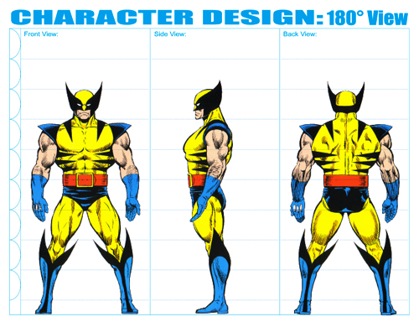
Grading Rubric – 5 points
An A grade will look like: 4 - 5 points
Your attention to detail is self evident. You followed the outline exactly as explained. You incorporated original thoughts and ideas. The artwork is personal, of your choice and of professional standards you set.

A B grade will look like: 3 - 4 points
Your attention to detail is evident in parts of your final. You followed the outline mostly as explained. You incorporated some original thoughts and ideas. Your idea and artwork is of professional standards, but has some room for revisions. Your letter may contain a few typos.

A C grade will look like: 2 - 3 points
Your attention to detail is evident in some of your final. You followed the outline mostly as explained, but are missing one or more key elements asked for. You incorporated a few original thoughts and ideas. The artwork is of minimal professional standards, has some room for improvements and revisions and should be corrected before mailing. Your letter has spelling and punctuation errors that should also be looked at before mailing.

A D grade will look like: 1 - 2 points
Your attention to detail is evident in almost no part your final. You did not follow the outline as explained, and are missing more than one key elements asked for. There is no thought given to originality. It’s minimal or even too much. The artwork is not of professional standards yet and should be corrected if giving this to a client. Your letter has spelling and usage issues. Maybe does not make much sense.

A Failing grade will mean: 0 - 1 points
The project is either not turned in, incomplete and there was no attention paid to the instructions provided. There is no thought given to originality. The artwork is not of professional standards. The idea most likely should have been abandoned in favor of another approach.

